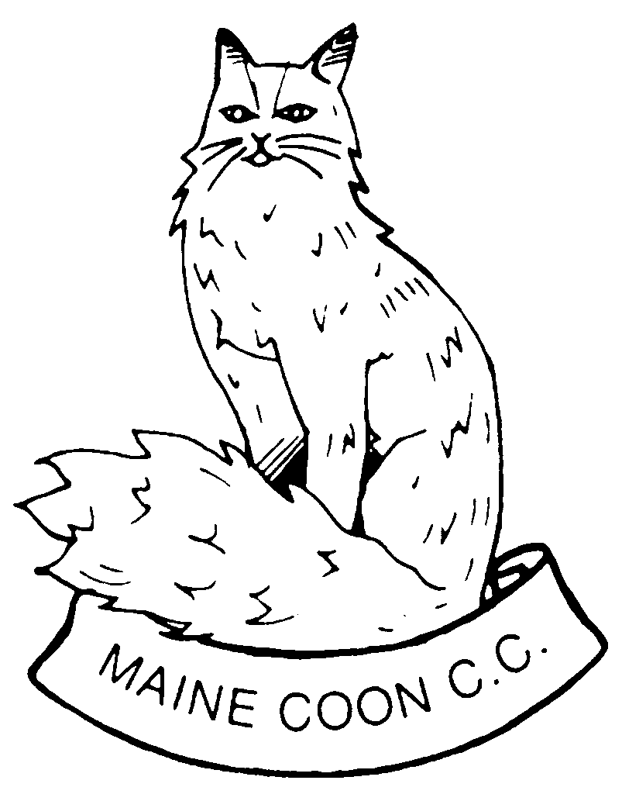
APPLICATION FOR MEMBERSHIP

Mr/Mrs/Miss/Ms ______________________________________________________
Wish to become members of the Maine Coon Cat Club.
If accepted I/we agree to abide by the rules of the Club and by any recommendations that may be made from time to time by the Governing Council of the Cat Fancy (GCCF).
SINGLE Subscription (£5 membership+£1 joining fee) £6.00 __________
JOINT Subscription (£7 membership+£2 joining fee) £9.00 __________
JUNIOR Subscription (up to 16yrs) (£2.50 membership+£1 joining fee) £3.50 __________
Please note that junior members do not have voting rights.
TOTAL __________

Preferred payment is by Bank Transfer (BACS) which can be made after the completed application form is received. The MCCC bank details will be supplied on request.
Payment can also be by a Cheque or PO made payable to the ‘MAINE COON CAT CLUB’

OUTCROSSES ARE NOT PERMITTED BETWEEN MAINE COONS AND ANY OTHER VARIETY OF PEDIGREE OR NON-PEDIGREE CATS

Your own G.C.C.F. Prefix (if any) ____________________________________________

Breeds of cats owned _____________________________________________________

Signed _________________________________ Date __________________________

Address _______________________________________________________________

______________________________________________________________________

__________________________________________Postcode_____________________

Tel Number ____________________Email____________________________________

The Maine Coon Cat Club Constitution requires that applicants are proposed by a current fully paid up club member, or a veterinary surgeon known to the applicant.
The veterinary surgeon's practice stamp should be put on the form.

Proposer's Name (Capitals please) __________________________________________________

Signature of Proposer ___________________________________________________

Please Note: GCCF Prefix Application Forms and MCCC Breeder List Application forms will only be signed or accepted after membership has been held for a minimum of twelve months.

Member’s contact details are kept on a computer database only accessed by the Membership and Club Secretaries and are used to send out information to our membership in the form of newsletters and mailshots. Members contact information is NOT given to any other club or organisation.

The completed application form can be emailed to mainecooncc@gmail.com or posted to:

MR STEVE BUTTERS
12 ST JOSEPHS ROAD
HANDSWORTH
SHEFFIELD
SOUTH YORKSHIRE, S13 9AU

